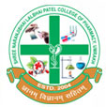
GUJARAT TECHNOLOGY UNIVERSITY
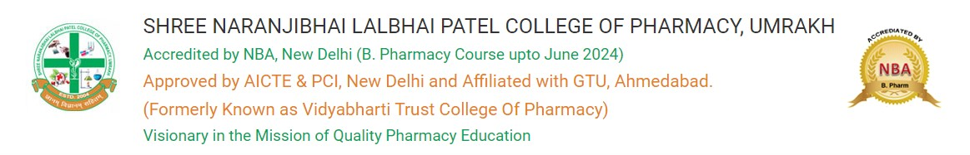

A report on Awareness Program: Creativity, Innovation and Entrepreneurship
Event Name: Creativity, Innovation and Entrepreneurship
Event Date: 21st August 2023
Brief Description of the Event:
On the auspicious occasion of World Entrepreneurship Day, the Entrepreneurship Development Cell and SSIP 2.0 organized a remarkable event titled "Creativity, Innovation and Entrepreneurship" at Shree Naranjibhai Lalbhai Patel College of Pharmacy, Umrakh, on 21st August 2023.
The event aimed to inspire and educate students about the vital role of creativity, innovation, and entrepreneurship in today's dynamic and competitive world. It brought together budding entrepreneurs, experienced industry professionals, and esteemed educators to share insights, experiences, and foster a culture of entrepreneurship among the participants.
Inauguration and Keynote Address:
The event commenced with a grand inauguration, marked by the lighting of the lamp by distinguished guests, faculty members, and student representatives. The keynote address was delivered by a renowned entrepreneur, Dr. Mulchand Sen, who shared his journey, emphasizing the importance of creativity and innovation in his entrepreneurial success.
The event featured hands-on workshops focused on enhancing creativity and fostering an entrepreneurial mindset. Participants actively participated in brainstorming sessions, idea generation exercises, and problem-solving activities, gaining practical insights into the entrepreneurial process.
Networking Opportunities:
The event provided ample networking opportunities, allowing participants to connect with like-minded individuals, industry professionals, and potential collaborators. Informal interactions facilitated the exchange of ideas and the formation of valuable connections for future entrepreneurial endeavours.
The "Creativity, Innovation and Entrepreneurship" event at Shree Naranjibhai Lalbhai Patel College of Pharmacy, Umrakh, successfully inspired and educated the participants about the critical role of creativity and innovation in the entrepreneurial landscape. The engaging sessions, interactive workshops, and networking opportunities contributed to creating a vibrant entrepreneurial ecosystem within the institution. The event served as a catalyst for nurturing the entrepreneurial spirit among the students, empowering them to embark on innovative ventures and contribute to the growth of the entrepreneurial ecosystem.
This event stands as a testament to the commitment of the Entrepreneurship Development Cell and SSIP 2.0 in fostering a culture of entrepreneurship and innovation, preparing the students for the challenges and opportunities of the dynamic business world. Dr. Biren Shah concluded the session with vote of thanks.

